JOINTS OF UPPER LIMB
Joints of shoulder girdle and upper arm
- Acromio – clavicular joint
- Sterno – clavicular joint
- Gleno-humeral joint (shoulder joint)
Joints of forearm
- Elbow joint
- Wrist joint
Joints of the hand
- Trapezio metacarpal joint (TM)
- Carpometa carpal joint (MCC)
- Metacarpo phalangeal joint (MCP)
- Interphalangeal joint (IP)
- Proximal interphalangeal joint (PIP)
- Distal interphalangeal joint (DIP)
Diagram showing joints of hand
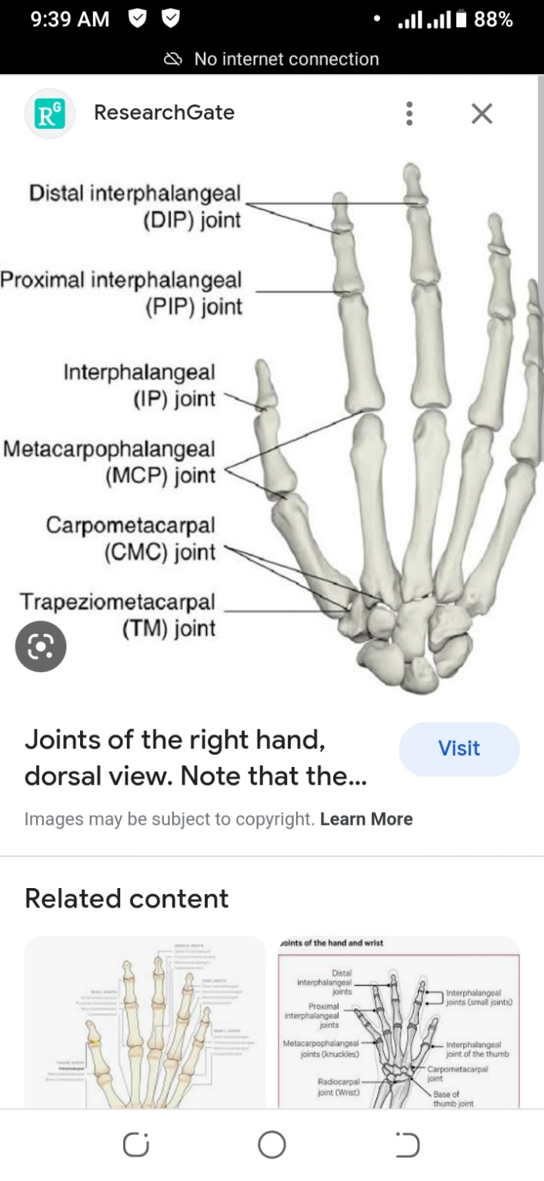
Shoulder joint
Type: Ball and socket joint
- It is also synovial
Articulating surfaces: Head of humerus (ball)
- Glenoid cavity of scapula (socket)
Structures in the joint
Joint capsule: This is a sac that contains lubricating fluid called synovial fluid.
- It encloses all sides of the shoulder joint.
Synovial membrane: Lines the joint capsule and produce synovial fluid for joint lubrication.
Ligaments: They are several and hold the joint firmly.
Bursae: They produce synovial fluid which reduce friction in the shoulder joint.
Stabilizers of shoulder joint
- Ligament
Coraco- clavicular ligament- This is composed of two ligaments (Trapezoid and conoid ligaments)
- It connects clavicle and coracoid process of scapula.
Gleno-humeral ligament – connects glenoid cavity of scapula to head of humerus.
Coraco-Humeral ligament- Connects coracoid process of scapula to greater tubercle of humerus.
Transverse humeral ligament – this span (circles) the greater and lesser tubercles of humerus.
Coraco-acromial ligament – connects coracoid process and acromion process of scapula
- Joint capsule- this encloses all sides of shoulder joint holding it firmly.
- Shape of articular surfaces- The head of humerus fits well in the glenoid fossa of scapula.
- Muscles of the shoulder- All muscles of the shoulder holds the joint firmly
Blood supply to shoulder joint
It is supplied by the following arteries.
- Circumflex (axillary) artery
- Suprascapular artery
- Sub scapula artery
Nerve supply to shoulder joint
It has three nerves
- Circumflex (axillary nerve)
- Musculo cutaneous nerve
- Supra scapula nerve
Movements of shoulder joint
- Flexion
- Extension
- Abduction
- Adduction
- Internal rotation
- External rotation
- Circumduction
Diagram of shoulder joint
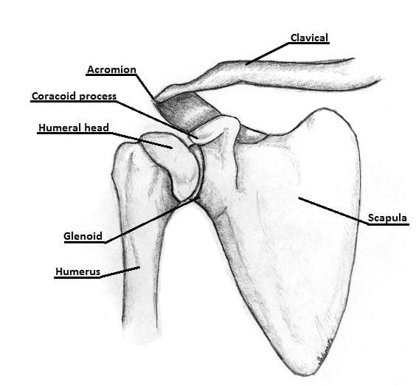
The Elbow joint
Type: It is a hinge joint
- It is also synovial
Articulatory surfaces: Trachlea of humerus and trachlea notch of ulna
- Capitulum of humerus and head of radius.
Structures in elbow joint
The capsule: This is a water tight sec that contains lubricating fluid called synovial fluid.
- It surrounds the elbow joint.
Synovial membrane: This lines the joint capsule. It produces synovial fluid for joint lubrication.
Blood supply to elbow joint
- Radial artery
Nerve supply
- Radial nerve
- Median nerve
- Musculo cutaneous nerve
- Ulna nerve
Stabilizers of elbow joint
- Ligaments – Medial (ulna) collateral ligament.
Lateral (radial) collateral ligament.
- Forming shape of articular surfaces.
- Joint capsule- it encloses all sides of the joint.
- Muscles that pass across the elbow joint.
Movements of elbow joint
- Flexion and
- Extension
Diagram showing the elbow joint
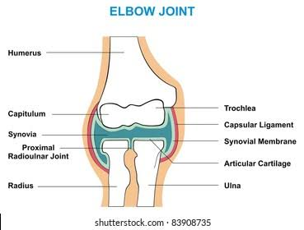
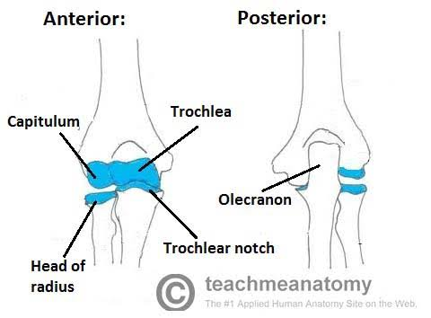
Radio-ulna joint
The radius and ulna are joined by three separate joints
- Proximal radio-ulna joint
- Middle radio-ulna union
- Distal radio-ulna joint
The proximal radio-ulna joint
Type: It is a pivot joint
- It is also synovial
Articulating surfaces: - Head of radius
- Radial notch of ulna
- Annular ligaments
NB/ The annular ligament is a strong fibrous band which attaches anterior and posterior sides of radial notch of ulna forming a complete ring where head of radius rotate.
The middle radio-ulna union
Type: It is a syndesmosis joint between shaft of radius and shaft of ulna
A syndesmosis joint is a fibrous joint in which adjacent bones are linked by a strong membrane or ligaments.
It is joined by two structures.
- Oblique cord- A small fibrous cord running from lateral side of ulna tuberosity downward and laterally to below radial tuberosity.
- The interosseous membrane- This connects the shaft of radius and ulna
The distal radio-ulna joint
Type: It is a pivot joint
- It is also synovial
Movements of radio-ulna joints
Pronation and supination of forearm
Diagram of radio-ulna joints
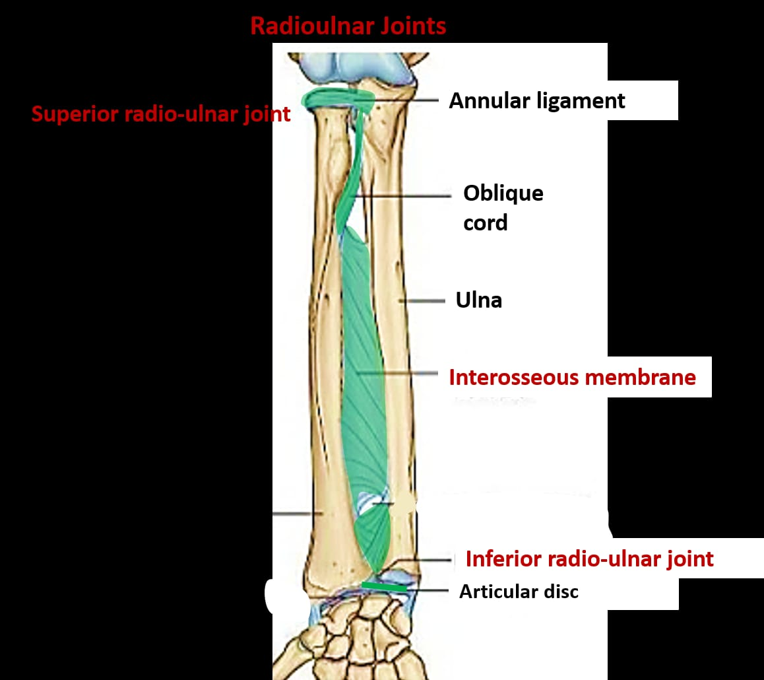
The wrist joint
Type: It is a condyloid (ellipsoid) joint
- It is also synovial
Articulating surfaces: Distal end of radius
- Carpal bones (scaphoid, lunate and triquetral)
Structures in the joint
Joint capsule- This is supports all the eight carpal bones.
Synovial membrane- This lines the joint capsule. It produces synovial fluid for joint lubrication.
Articular disk – A triangular shaped structure placed below distal end of ulna which binds lower end of ulna and radius together firmly.
Blood supply to wrist joint
- Radial artery
- Ulna artery
Nerve supply to wrist joint
- Median nerve
- Radial nerve
- Ulna nerve
Stabilizers of wrist joint
Ligaments
- Scapho-lunate ligament – connect scaphoid and lunate bones.
- Anterior radio carpal ligaments- connect distal end of radius and scaphoid, lunate and capitate bones on the anterior aspect of the joint.
- Radio-collateral ligament- connect styloid process of radius and scaphoid bone.
Joint capsule – This binds all the eight carpal bones.
Movements of wrist joint
- Flexion
- Extension
- Abduction (Radial deviation)
- Adduction (Ulna deviation)
Diagram of the wrist joint
